Terraform challenge
- Create an EC2 instance on AWS cloud using the below-mentioned ubuntu AMI and Instance_type. Or(you can use of your choice as well) ami = "ami-0461b1436c9b3c1a3" instance_type =
"t2.micro"

Main.tf
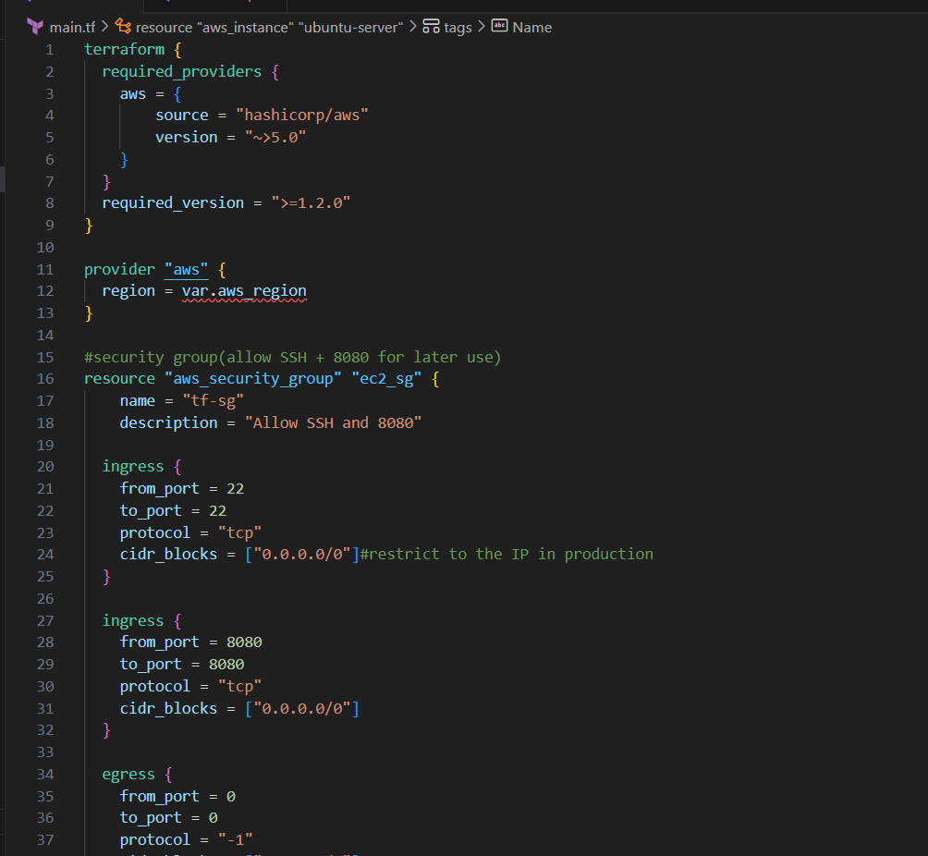
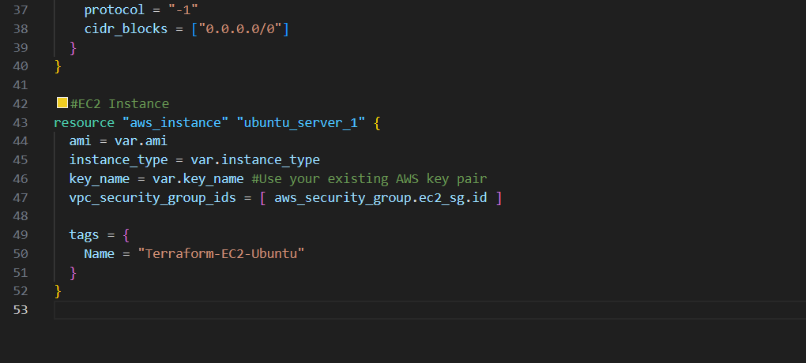
variable.tf
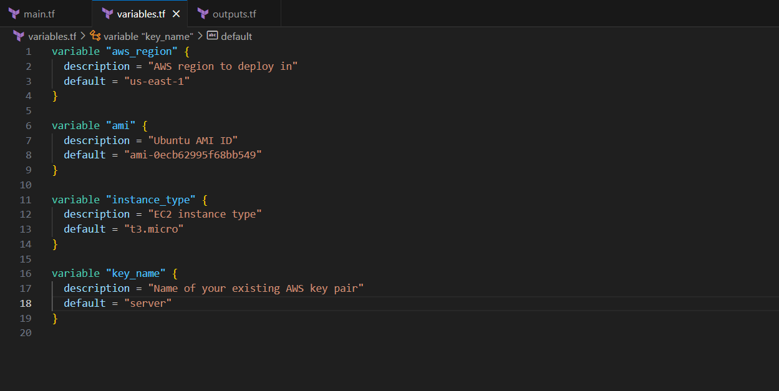

Outputs.tf
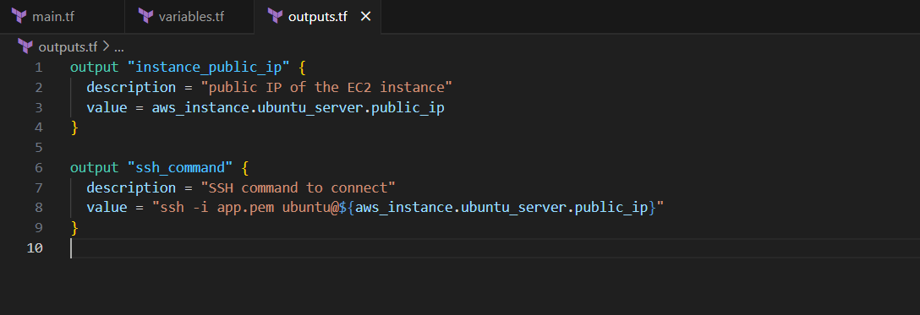
terraform init -upgrade
terraform apply
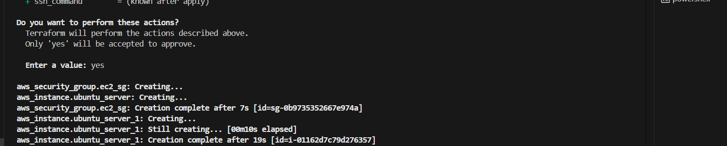

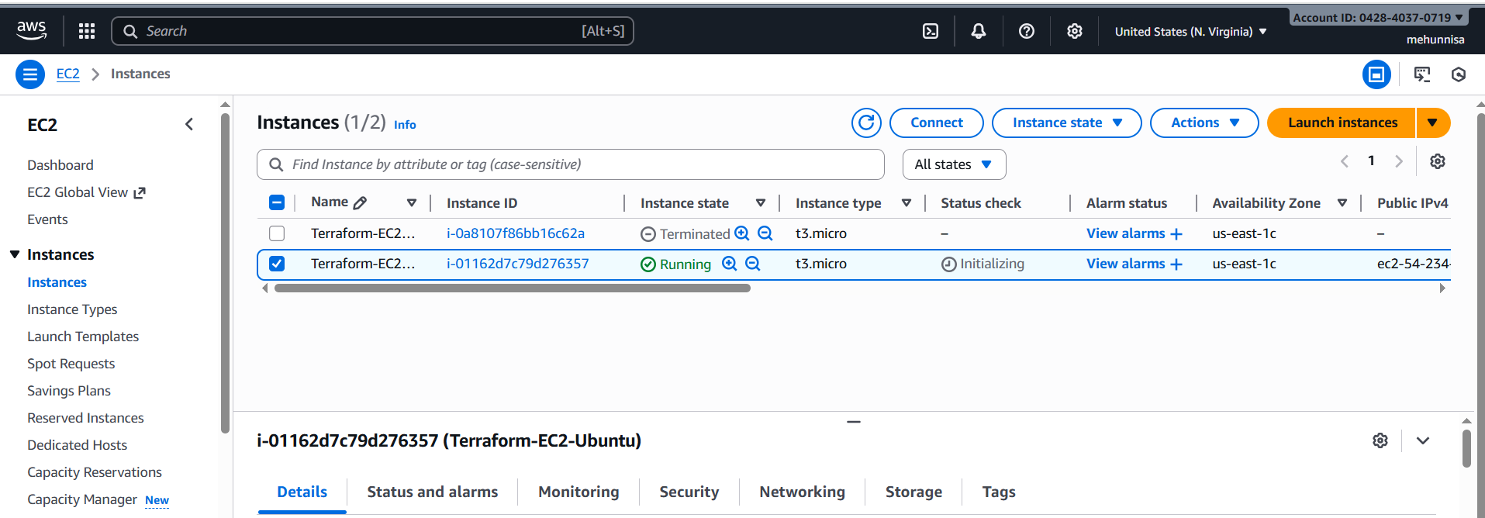
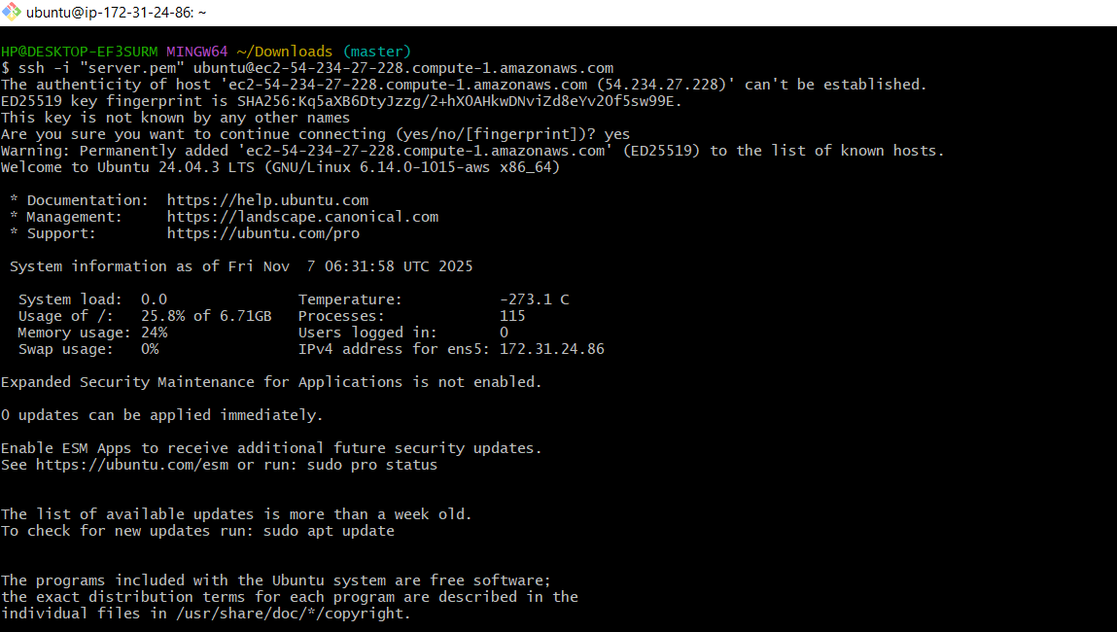
- Install a web server on the same EC2 Instance. The web server should listen on port 8080.
Main.tf
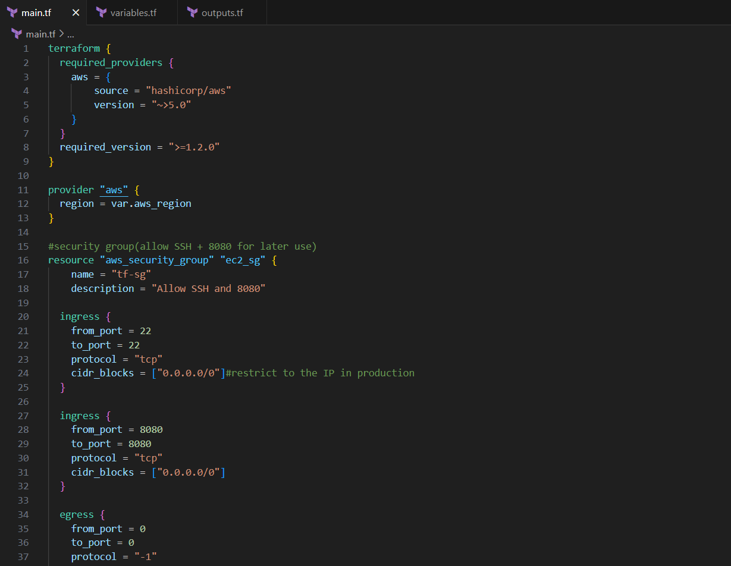
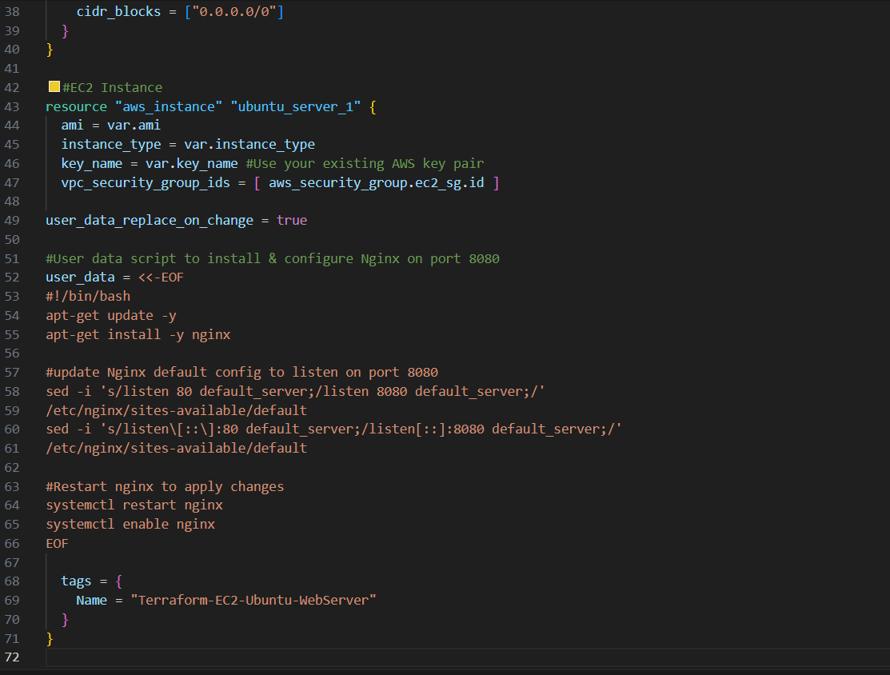
Variables.tf
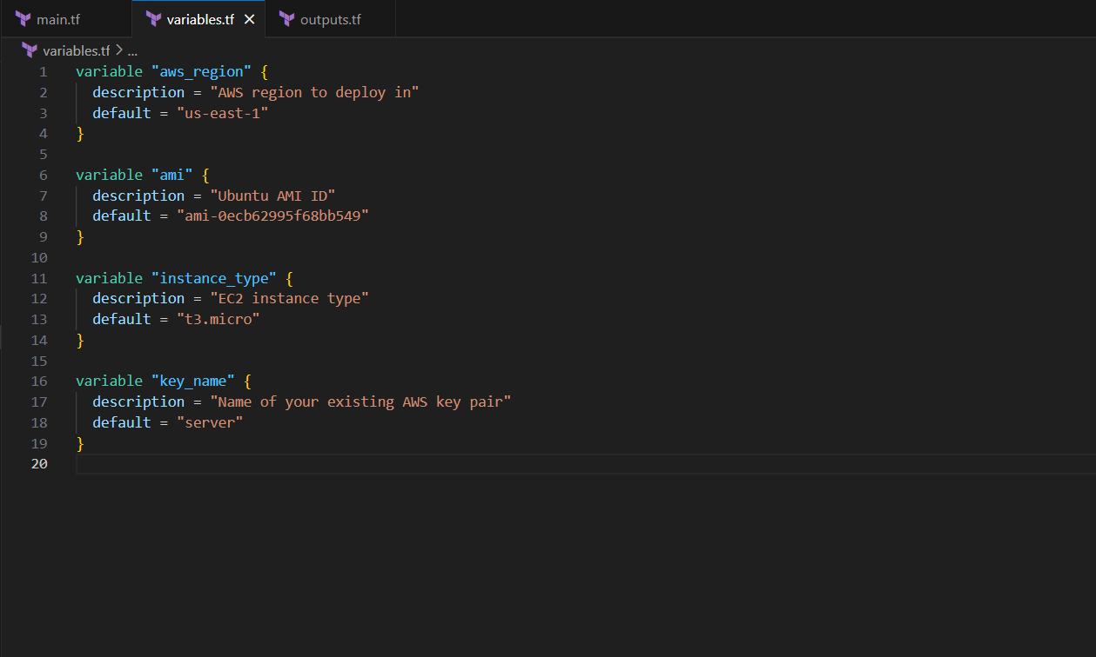

Outputs.tf
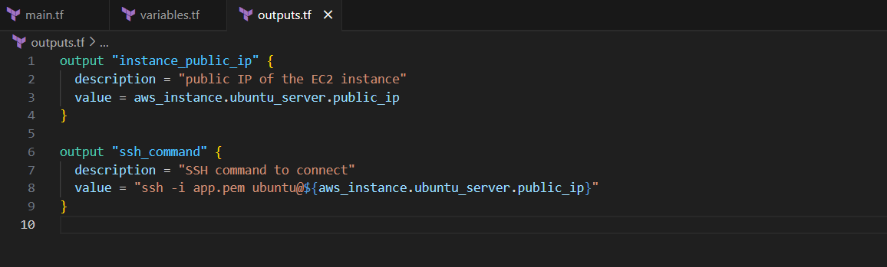

terraform init
terraform apply
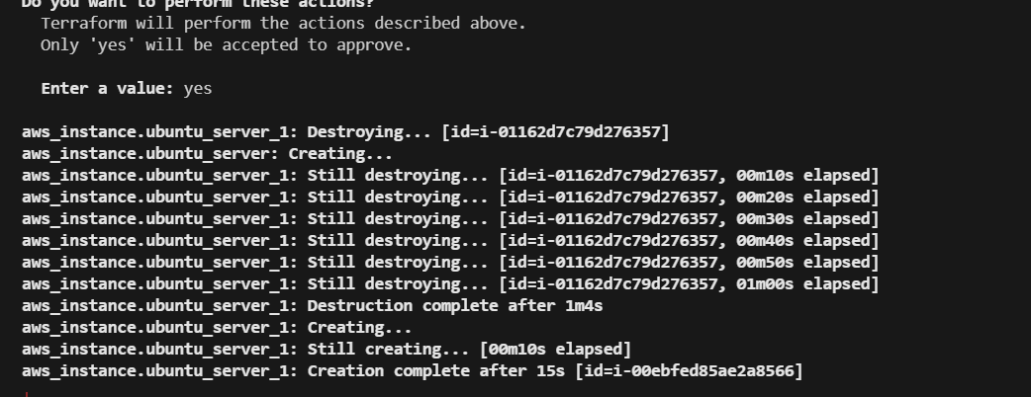

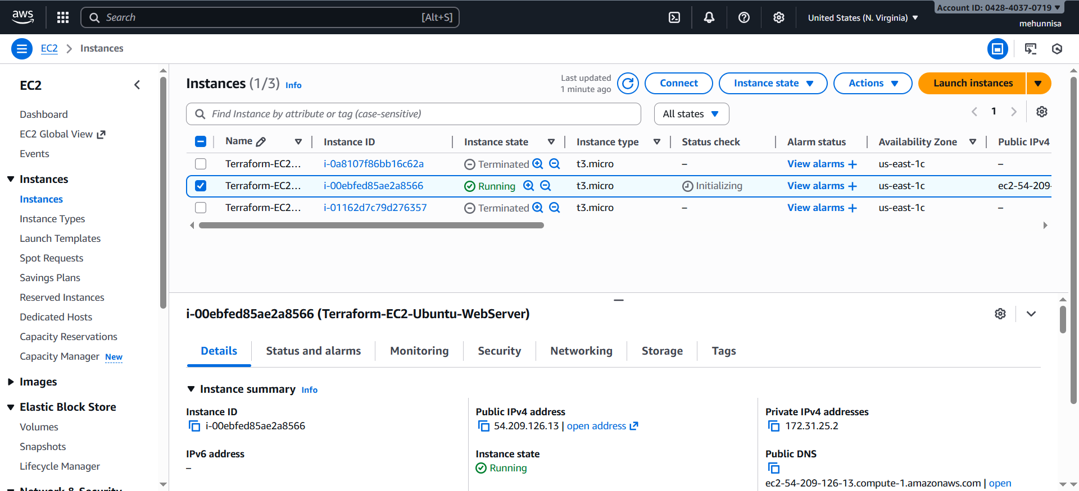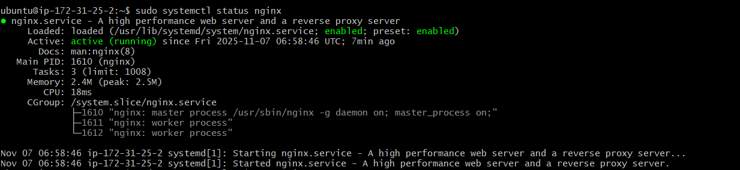

verify in browse whether it is working or not.
http://54.209.126.13:8080

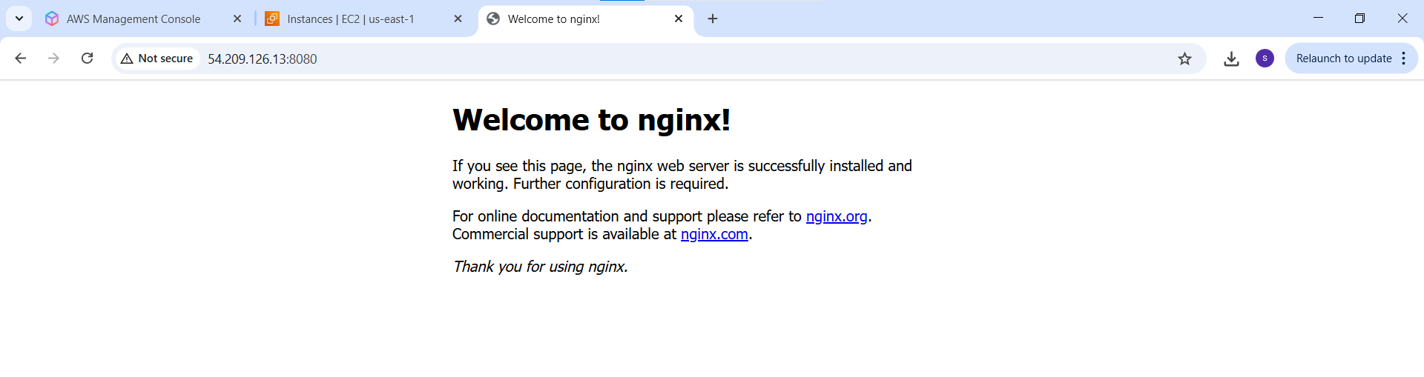
- Create a docker-compose file for the project:
https://github.com/betawins/cricbuzz-docker-hello-world.git and point it to port 8000.

Main.tf
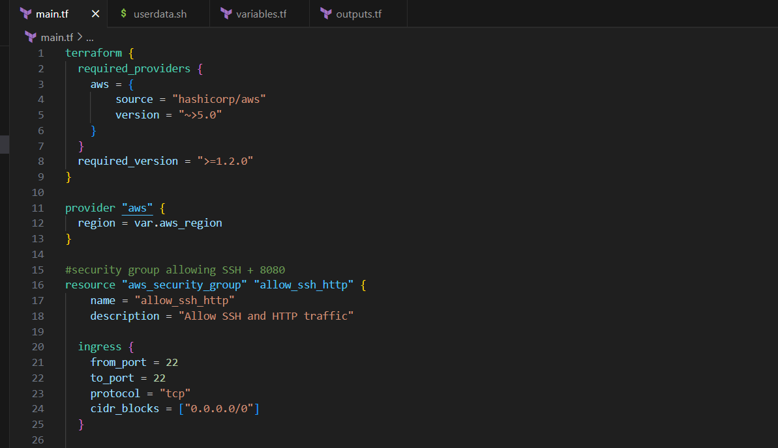
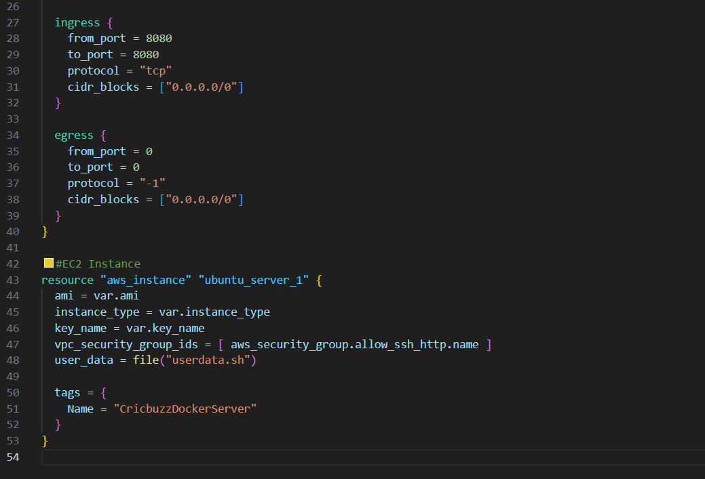

Outputs.tf
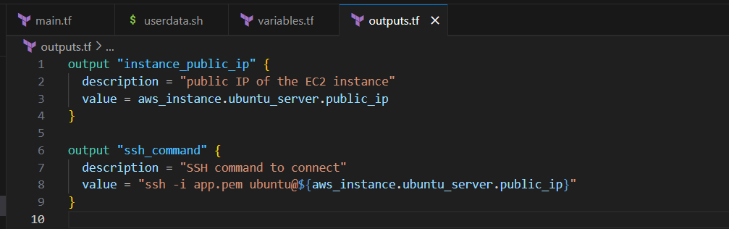

Userdata.sh
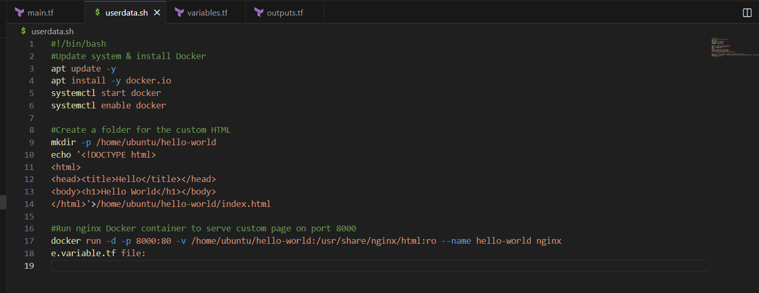

Variables.tf
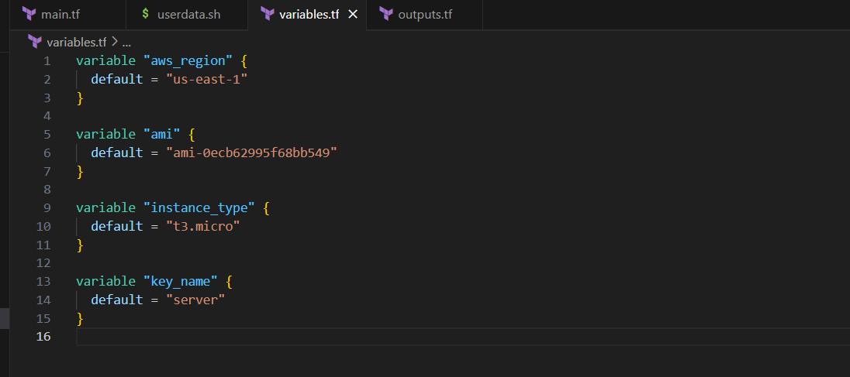
terraform init
terraform apply
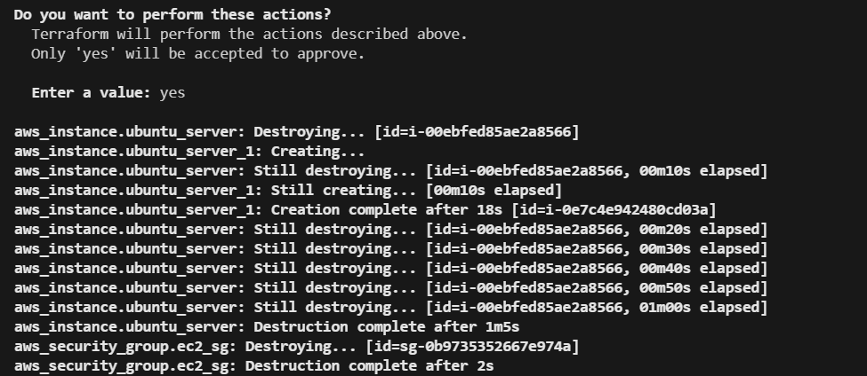

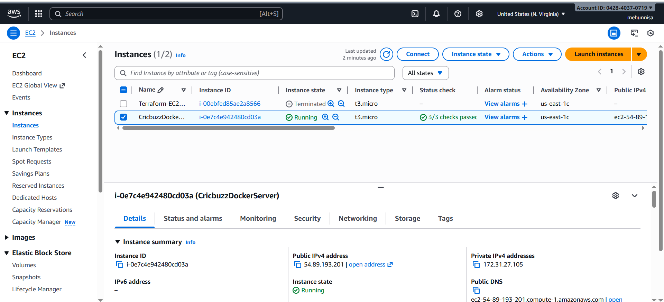
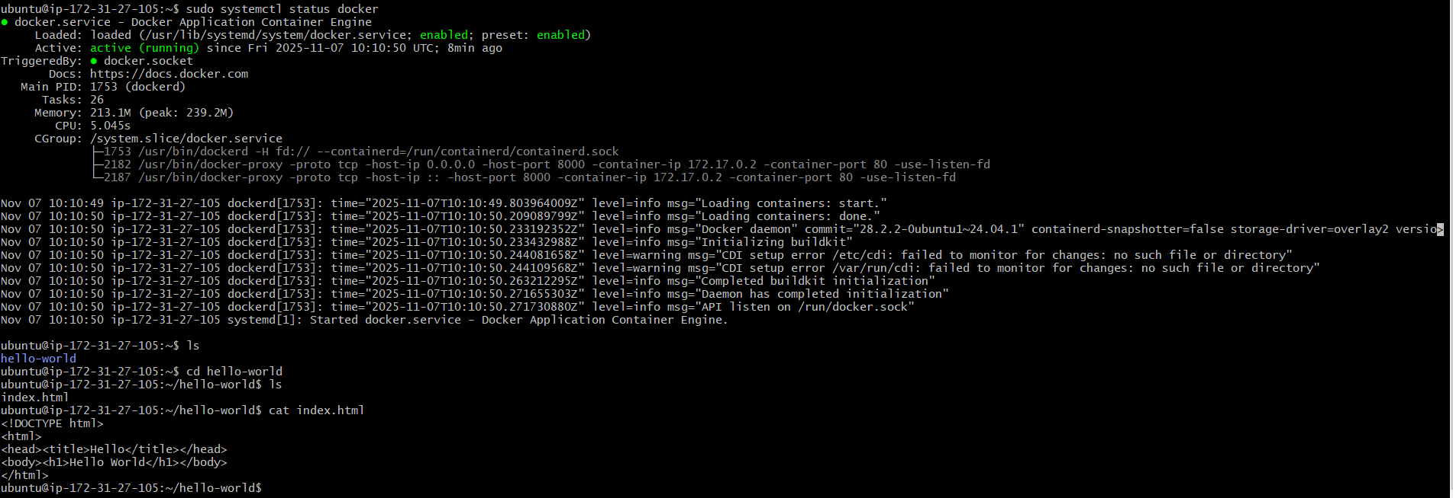
check in the browser whether it is running or not.
http://54.89.193.201:8000
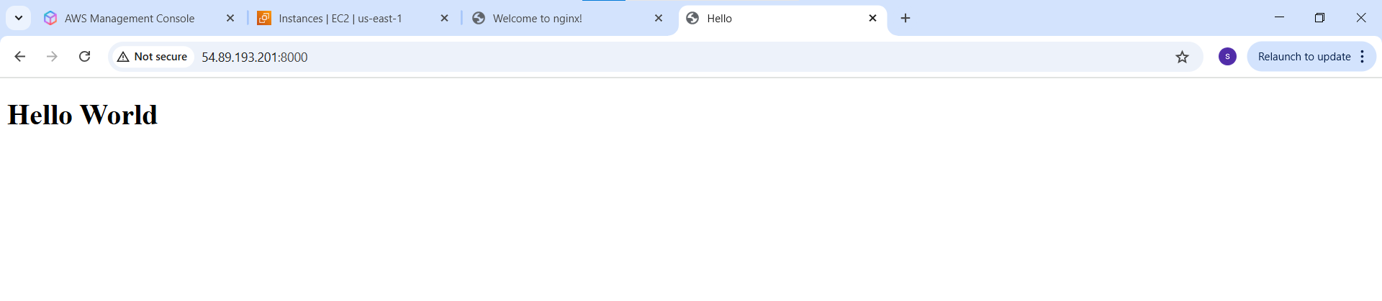4. Make the webserver point to the above service so that 8080 returns the response from the Docker service.
Main.tf
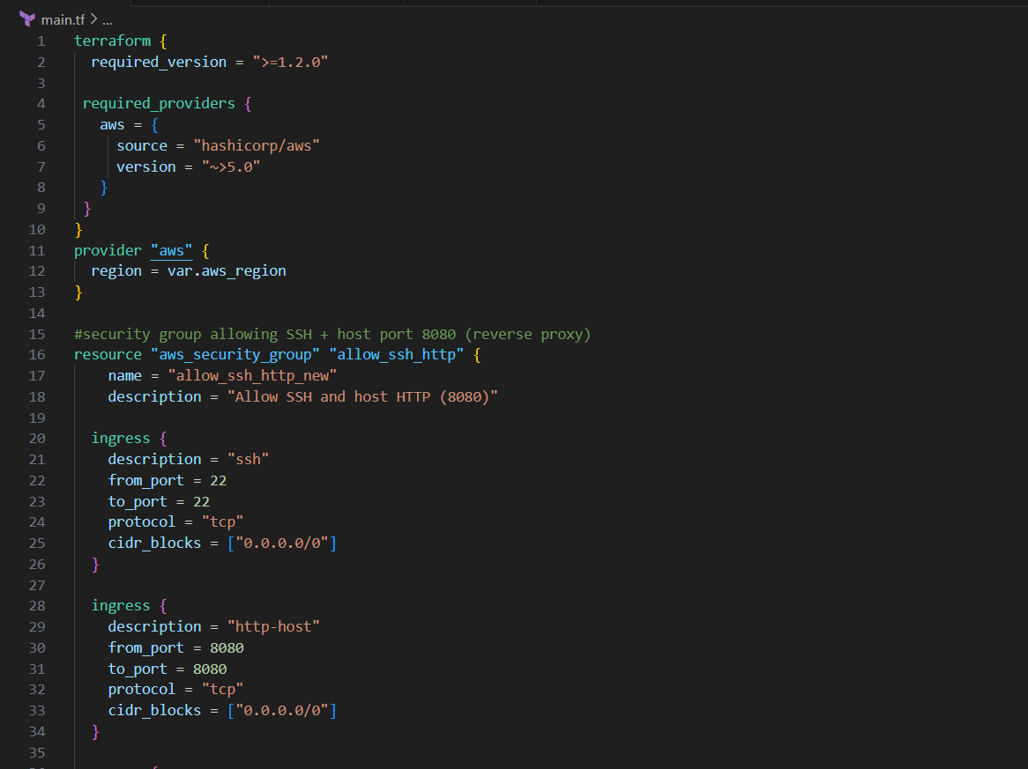

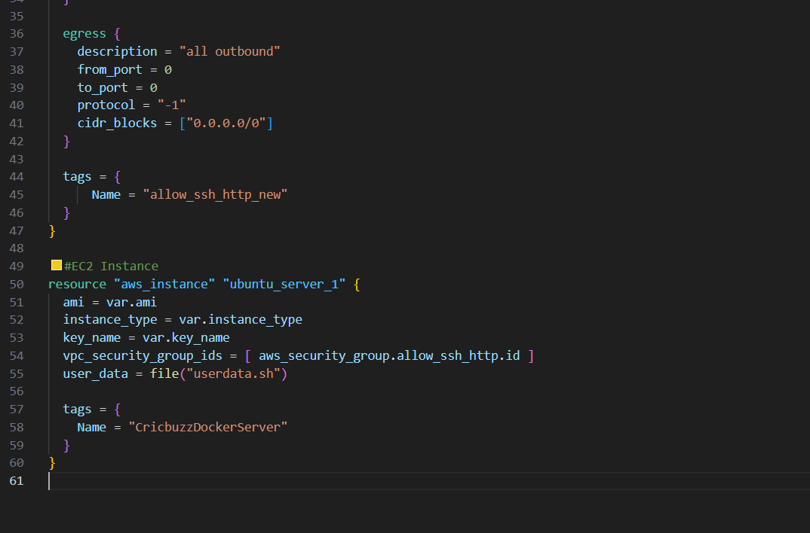

Outputs.tf
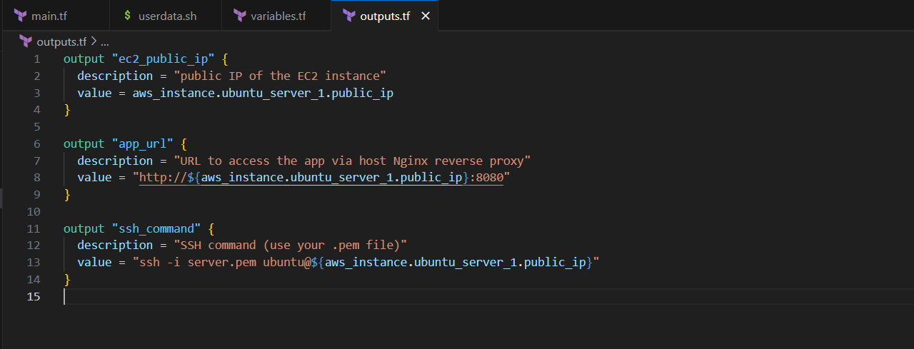

Userdata.sh
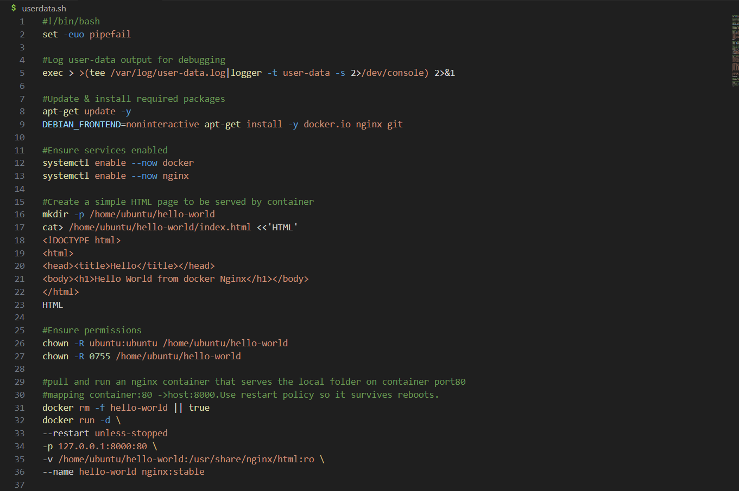

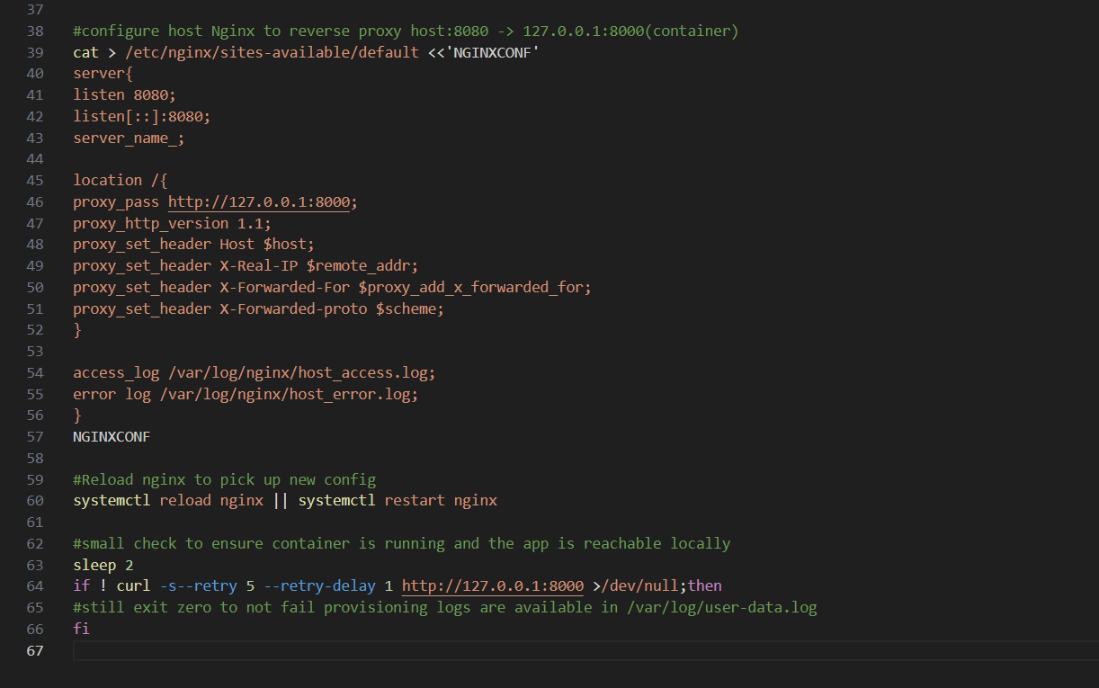
Variables.tf
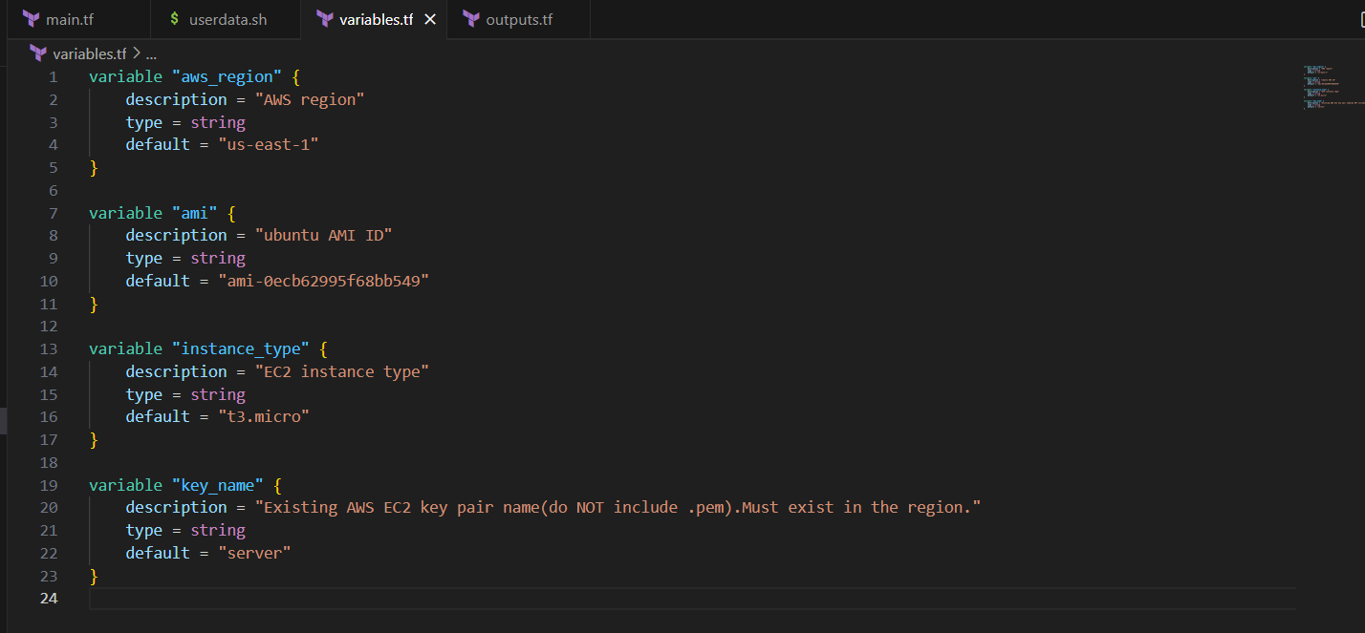
terraform init
terraform apply
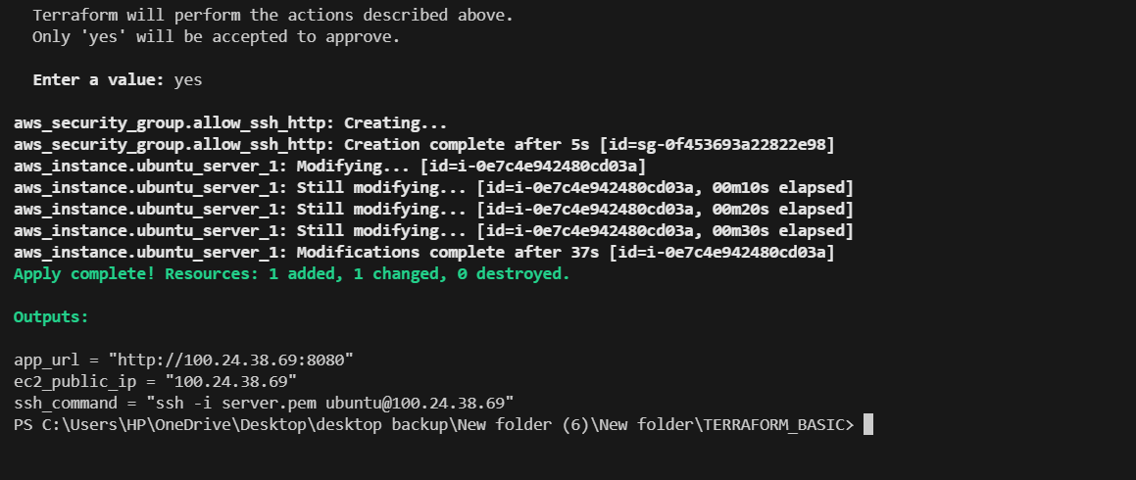
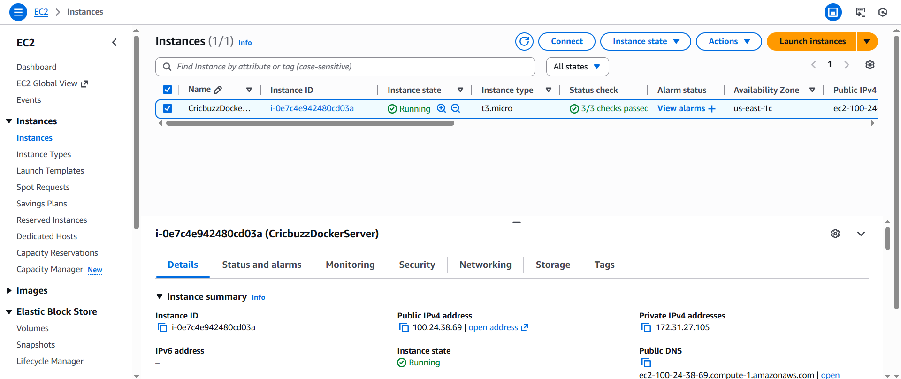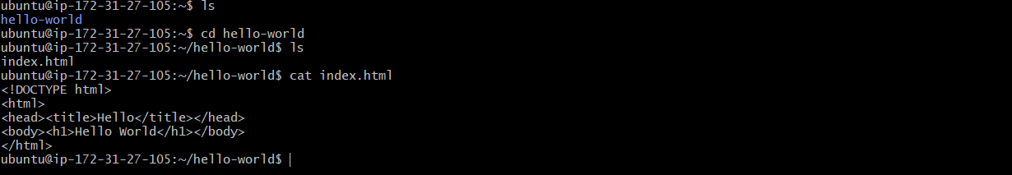

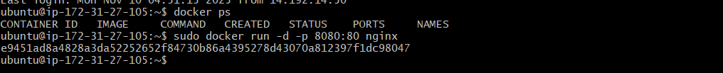

Checking in browser with public-ip whether it is working or not
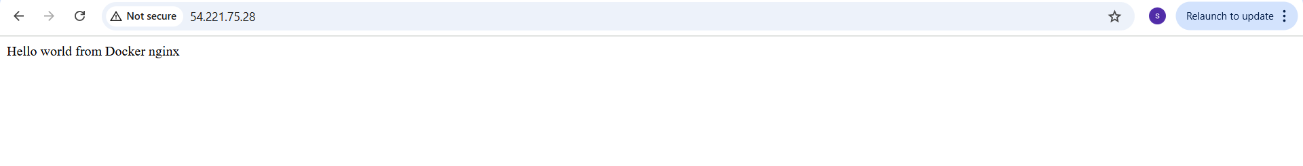
5. Configure to save the logs in the location /var/log/cb.log
Main.tf
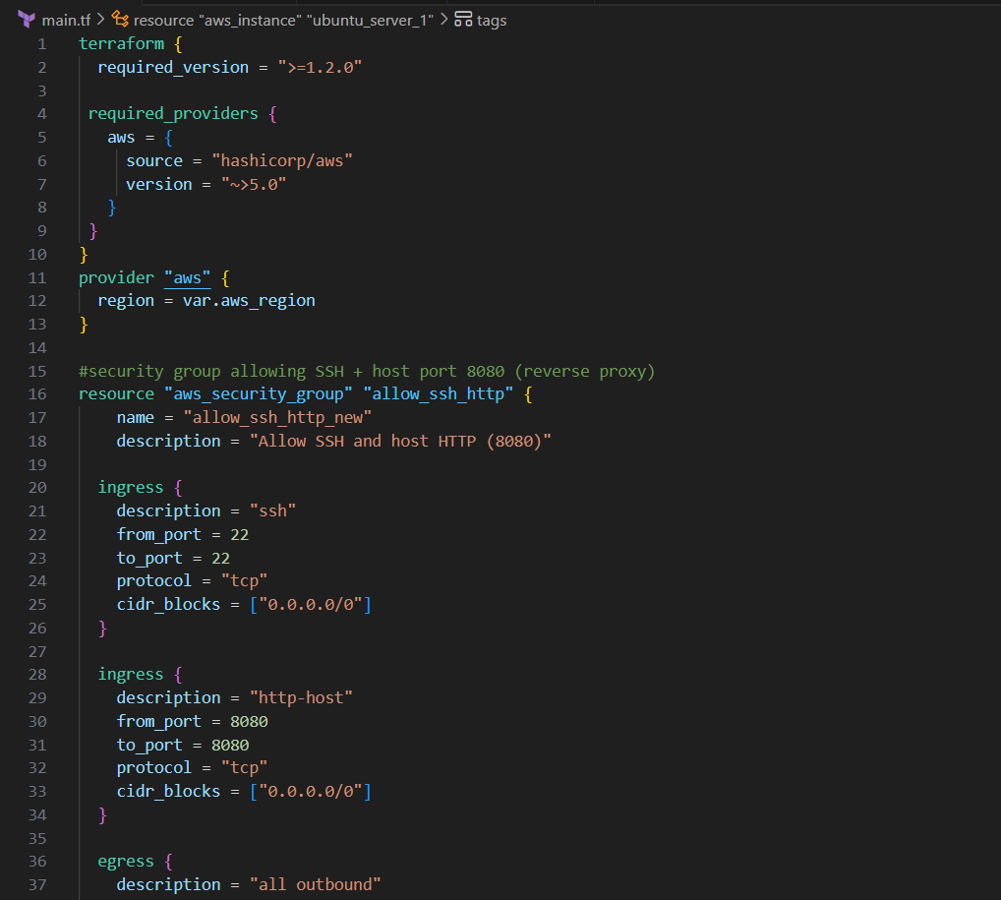
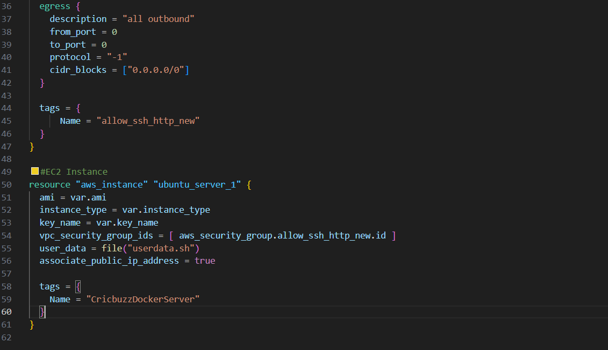

Outputs.tf
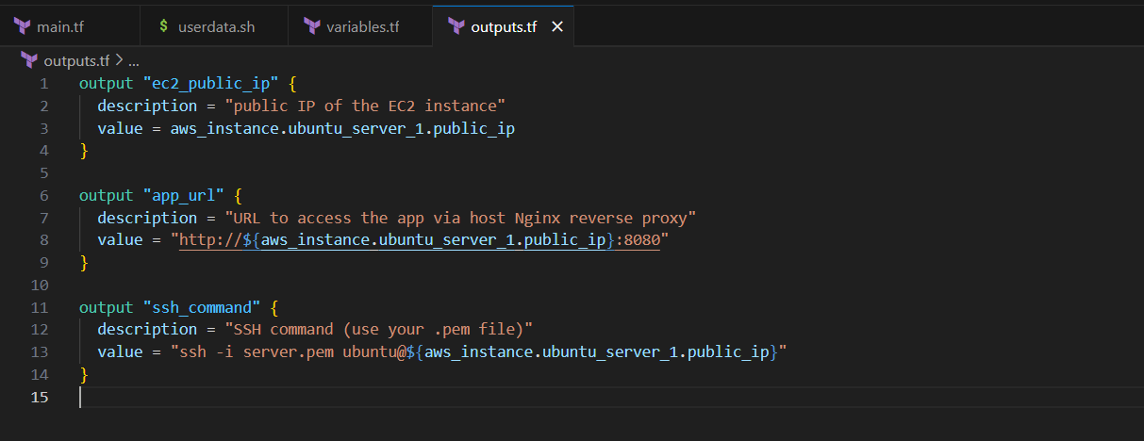

Userdata.sh
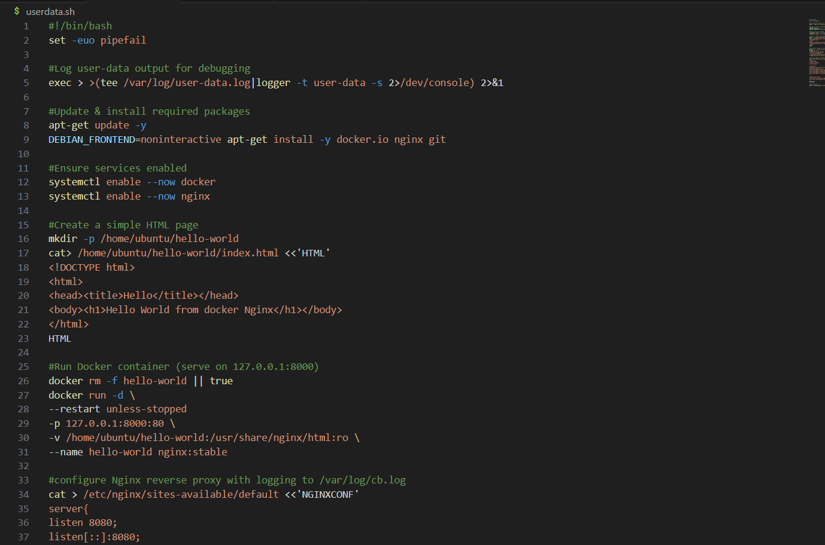

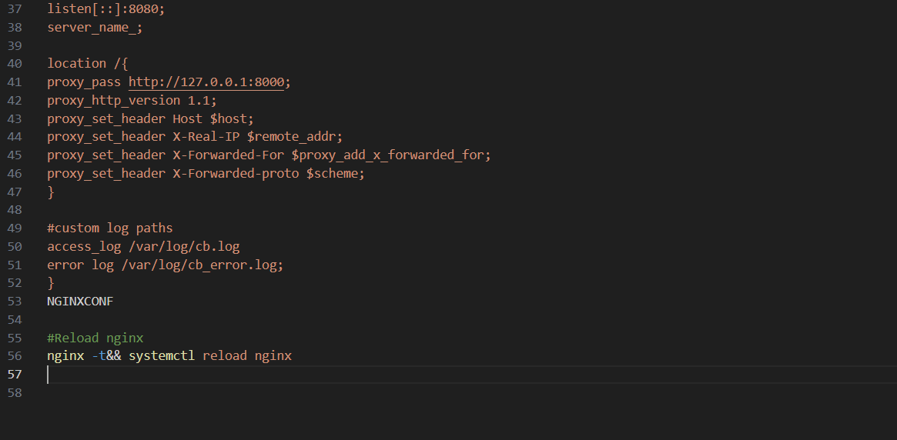

Variables.tf
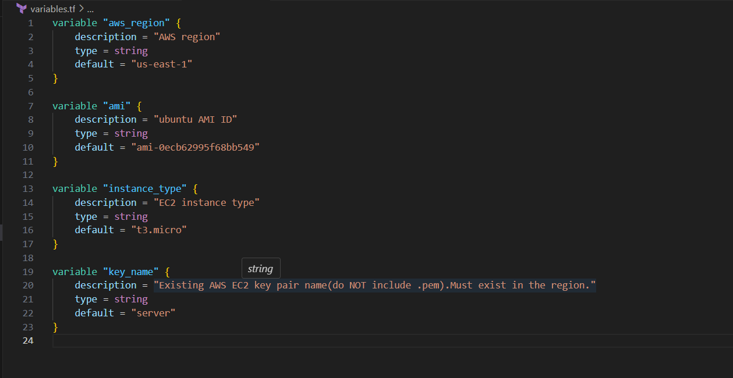

terraform init
terraform apply
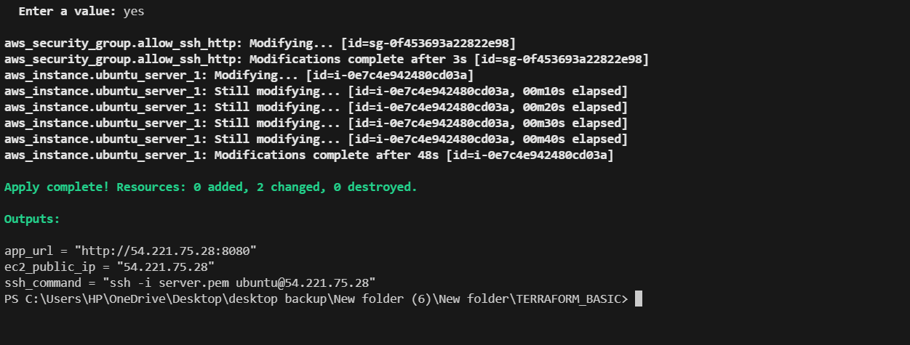
logfiles are located in different file.
access_log:var/log/nginx/host_access.log
error_log: var/log/nginx/host_error.log

since my nginx is running inside docker, nginx logs are also inside the container not on host.
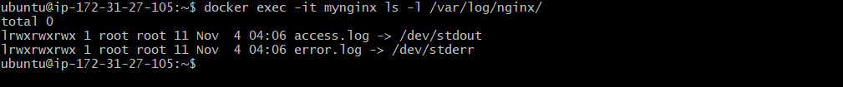

Nginx inside the docker container does not store logs in files.
It sends logs to docker’s standard output.
So logs will not appear in /var/log/nginx/access.log
Instead, the logs are available only with
docker logs mynginx 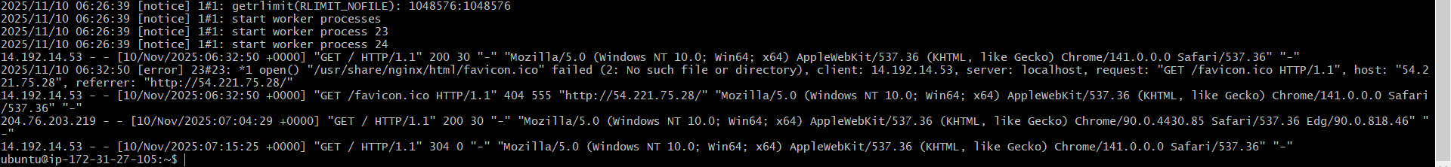

To view only access_logs in real-time
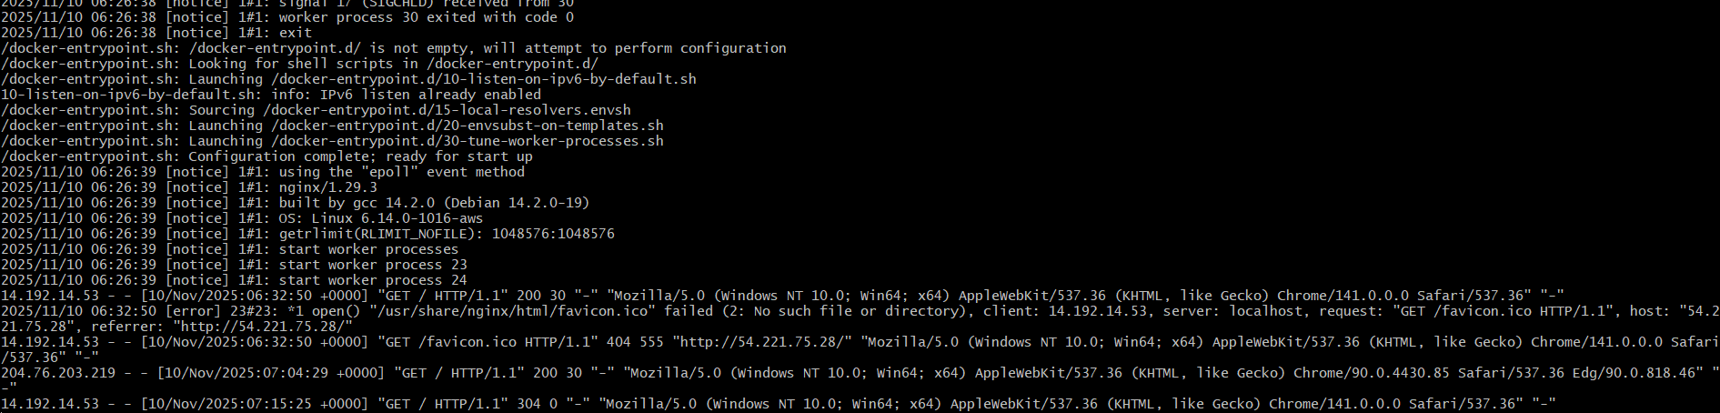

error_logs:

Tail logs:

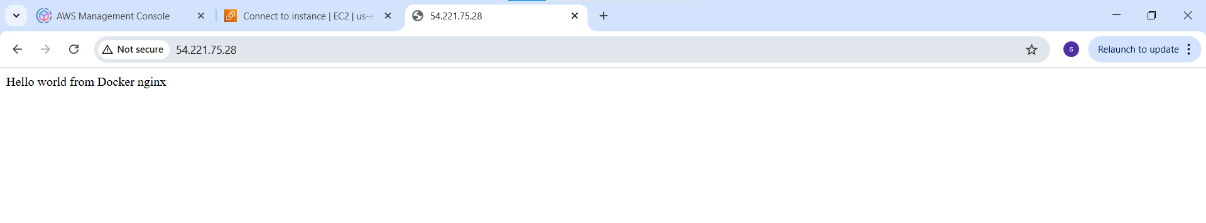

6. Write the log rotate configuration for the above file.
Sudo nano /etc/logrotate.d/apache2
Paste this in sudo nano /etc/logrotate.d/apache2
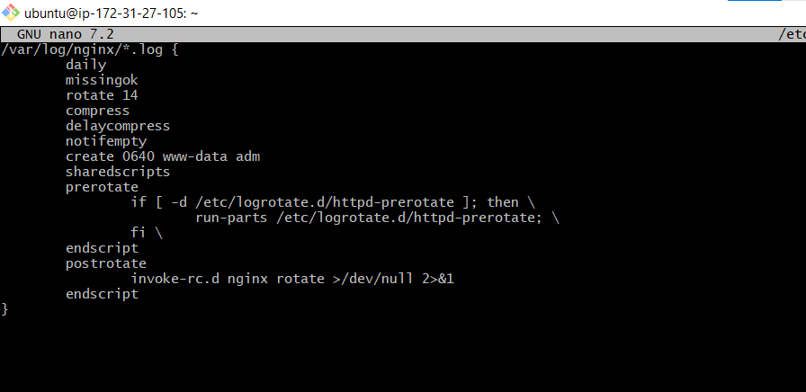
Test if log rotate will work
Sudo logrotate -d /etc/logrotate.d/apache2
